***SENTIMENT ANALYSIS***

**Introduction:**

Sentiment analysis, a vital component of natural language processing (NLP), focuses on extracting sentiments expressed in text data. In this project, we aim to develop a sentiment analysis system using the Flipkart dataset, which comprises product information, ratings, reviews, summaries, and sentiments.

The ever-increasing volume of online shopping and customer feedback has made it crucial for businesses to analyze and understand customer sentiments effectively. By leveraging sentiment analysis techniques, companies can gain valuable insights into customer experiences, product satisfaction, and brand perception.

The objectives of this project are twofold. Firstly, we will implement machine learning algorithms to build a sentiment analysis model capable of accurately categorizing text data into sentiment labels such as positive, negative, or neutral. Secondly, we will evaluate the performance of our developed model using appropriate evaluation metrics and compare it with other existing approaches.

The Flipkart dataset offers a diverse range of product information, ratings, reviews, and summaries, making it an ideal resource for training and testing our sentiment analysis model. By analyzing customer sentiments expressed in the dataset, we can uncover patterns, identify potential issues, and provide valuable insights for product improvement and customer satisfaction.

Sentiment analysis has broad applications across multiple domains. In the e-commerce industry, it helps businesses understand customer preferences, enhance product recommendations, and optimize marketing strategies. Additionally, sentiment analysis can be utilized in market research to gauge consumer sentiment towards different brands, products, or services.

Throughout this report, we will provide a comprehensive overview of the sentiment analysis problem statement, describe our data collection and preprocessing methods, present the machine learning models employed, evaluate their performance using appropriate metrics, and conclude with insights and recommendations based on our findings.

**Data collection:**

The Flipkart dataset used in this project was obtained from Kaggle, a popular platform for sharing and discovering datasets. The dataset comprises product information, ratings, reviews, summaries, and sentiment labels, making it a valuable resource for sentiment analysis. The dataset was collected and curated by contributors on Kaggle, ensuring its reliability and relevance for our analysis. By leveraging this dataset, we were able to access a comprehensive collection of customer feedback from Flipkart, enabling us to perform accurate sentiment analysis and derive meaningful insights.

**Data Preprocessing:**

Data preprocessing plays a crucial role in the success of any machine learning project, including sentiment analysis. In this section, we will discuss the steps taken to collect and preprocess the Flipkart dataset to ensure its suitability for sentiment analysis.

**Data Cleaning:**To ensure the quality and reliability of the data, several cleaning steps were performed on the Flipkart dataset.

**Removal of irrelevant data:** Any irrelevant information that does not contribute to sentiment analysis, such as product name, Product Price was removed from the dataset.

**Handling missing data:** The Flipkart dataset had a significant number of missing reviews, approx 24,000 instances. To address this, we filled in the missing reviews based on the associated ratings. Since the rating given by customers can provide insights into their sentiment, we used this information to approximate the missing reviews. By imputing the missing data in this way, we ensured that the dataset remained complete and suitable for sentiment analysis.

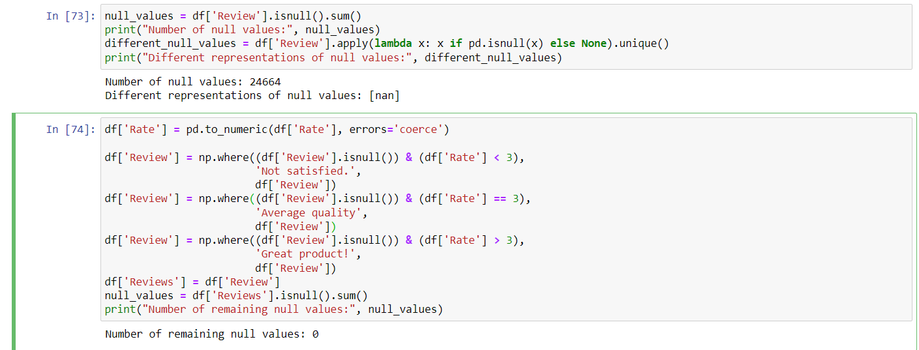

窗体底端

窗体底端

**Text preprocessing:** The textual data, including reviews and summaries, underwent several preprocessing steps to prepare it for sentiment analysis. These steps included tokenization, lowercasing, removal of punctuation and special characters, and the removal of stop words. Additionally, lemmatization was performed to further refine the text data.

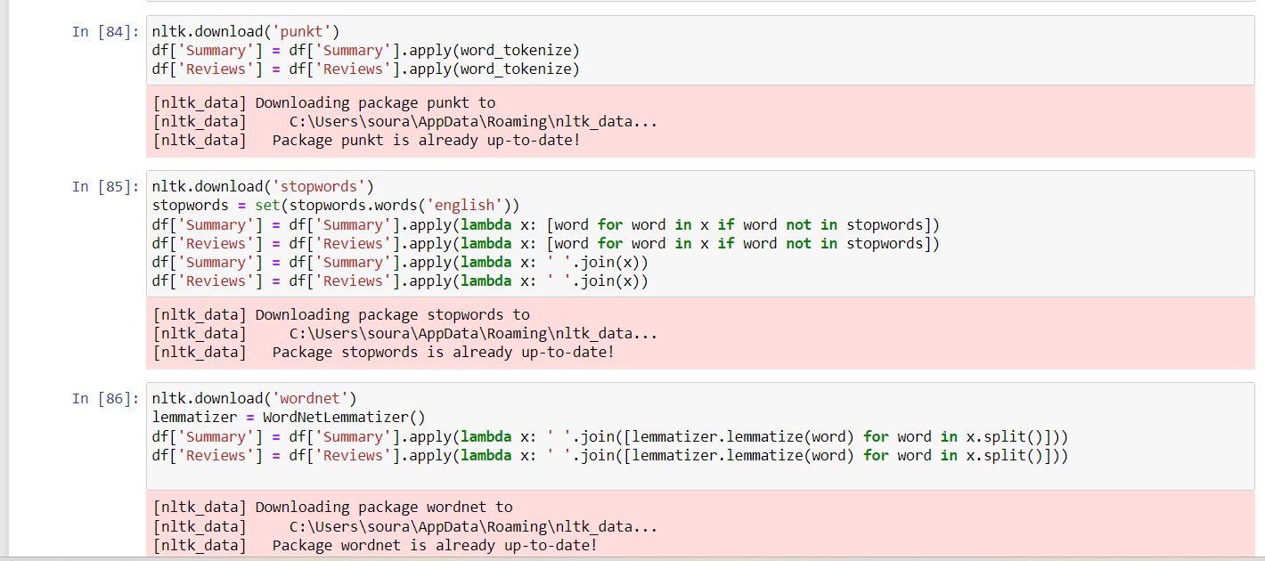

**Handling imbalanced classes:** To address the imbalanced class distribution in the Flipkart dataset, a combination of oversampling and undersampling techniques was applied. Oversampling involved randomly duplicating instances from the minority classes (negative and neutral sentiments), while By combining these approaches, we achieved a more balanced representation of sentiments in the dataset, allowing the sentiment analysis models to effectively learn from all sentiment categories and make accurate predictions.

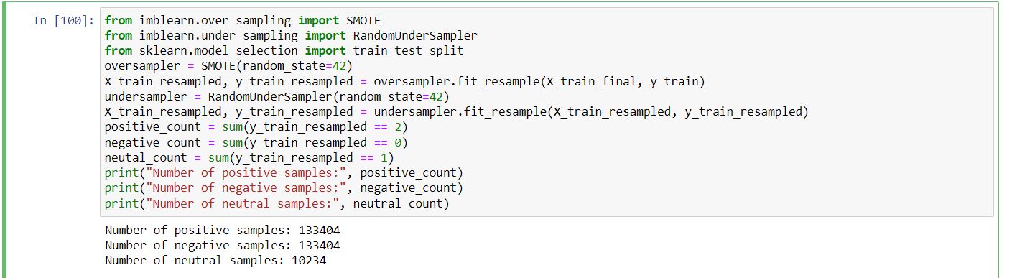

**Feature Engineering:**

Feature engineering plays a crucial role in sentiment analysis by transforming raw textual data into a numerical representation that machine learning models can effectively utilize. In this project, the TF-IDF (Term Frequency-Inverse Document Frequency) technique was employed as a feature engineering method to extract meaningful features from the text data.

**TF-IDF (Term Frequency-Inverse Document Frequency):**

TF-IDF is a widely used technique in natural language processing for feature extraction. It calculates the importance of a word within a document by considering its frequency (TF) and rarity across the entire corpus (IDF). This approach aims to highlight words that are both frequent within a document and rare in the larger context of the dataset.

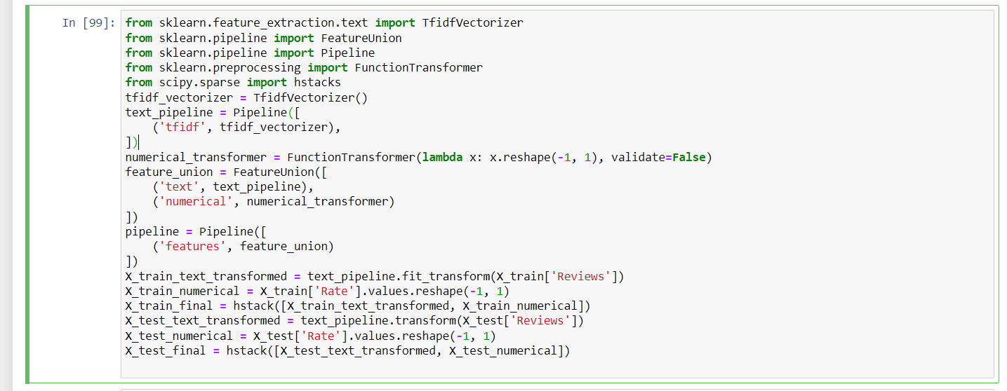

The provided code snippet demonstrates the implementation of a feature engineering pipeline for sentiment analysis. It includes the following steps:

**TF-IDF Vectorization:** The text data is transformed using TF-IDF vectorization, which assigns weights to words based on their frequency and rarity across the dataset.

**Numerical Feature Transformation:** The numerical features are reshaped to a suitable format for analysis using the FunctionTransformer.

**Feature Union:** The text and numerical features are combined using the FeatureUnion, creating a unified representation of the data.

**Pipeline Construction:** The pipeline is constructed by incorporating the feature union step.

**Data Transformation:** The training and testing data are transformed by applying the text pipeline to the text data and reshaping the numerical data. The transformed data is then combined to create the final feature representation.

**Data Visualization:**

Data visualization plays a crucial role in understanding the characteristics and patterns present in the dataset. In the context of sentiment analysis, visualizations can provide insights into the distribution of sentiment labels and the relationship between features and sentiment. Here are some examples of data visualizations that were generated from the Flipkart dataset:

**Word Cloud of Most Frequent Words:**

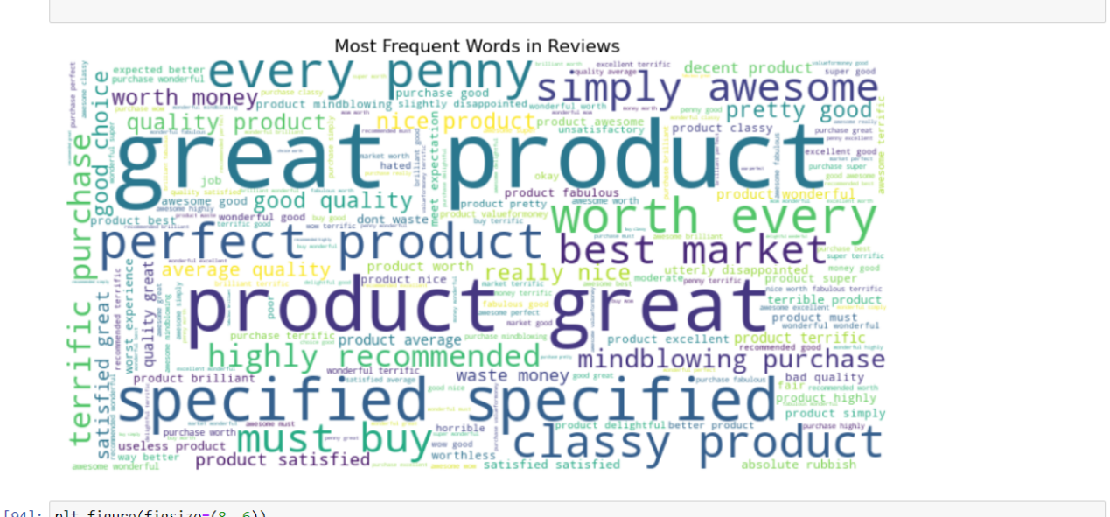

In the generated word cloud, the larger words indicate the most frequently used words in the dataset, while smaller words represent less common ones. This visualization helps in understanding the prominent words associated with sentiment, enabling us to identify key themes and expressions expressed by customers in their reviews.

**Distribution of Ratings by sentiments:**

Another important visualization in sentiment analysis is the distribution of ratings. This visualization provides insights into the ratings given by customers and their corresponding sentiment labels.

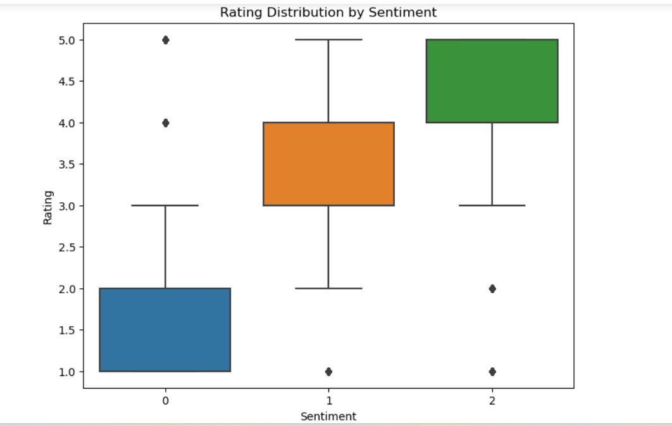

A boxplot is used to represent the distribution of ratings for each sentiment label in the dataset. The x-axis represents the different sentiment labels (e.g., positive, negative, neutral), and the y-axis represents the rating values.

**Model Training and Evaluation:**

To assess the performance of sentiment analysis models, the dataset was divided into training and testing sets using a train-test split strategy. The training set was used to train the models, while the testing set was reserved for evaluating their performance on unseen data.

The imbalanced distribution of sentiment labels in the dataset was addressed by employing resampling techniques. Both oversampling and undersampling methods were applied to achieve a more balanced representation of sentiment labels in the training data.

After resampling, three machine learning models were trained: logistic regression, XGBoost, and random forest

**Logistic Regression Model**

Logistic regression is a commonly used classification algorithm that predicts the probability of a sample belonging to a specific class. Here's a summary of the performance metrics obtained from the logistic regression model:

**Precision:**

Negative sentiment (class 0): 0.84

Neutral sentiment (class 1): 0.17

Positive sentiment (class 2): 0.96

**Recall**:

Negative sentiment (class 0): 0.83

Neutral sentiment (class 1): 0.40

Positive sentiment (class 2): 0.88

**F1-score:**

Negative sentiment (class 0): 0.84

Neutral sentiment (class 1): 0.24

Positive sentiment (class 2): 0.92

**Accuracy: 0.85**

These results indicate that the logistic regression model achieved relatively high precision and recall for the negative and positive sentiments, but lower performance for the neutral sentiment.

Overall, the logistic regression model demonstrates effectiveness in classifying sentiments in the Flipkart dataset. Further analysis and optimization can be done to improve the model's performance, particularly for the neutral sentiment class.

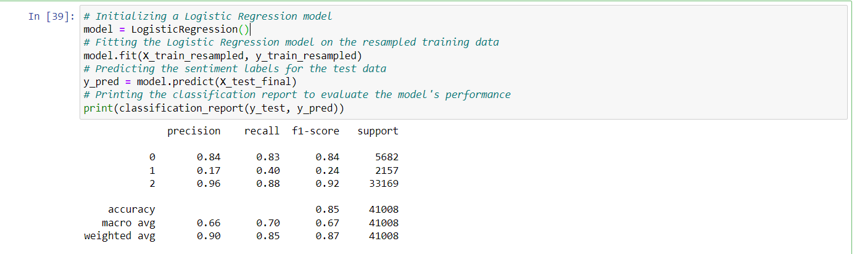

**Random Forest Classifier Model**

The Random Forest classifier was employed for sentiment analysis on the Flipkart dataset. Random Forest is an ensemble learning method that combines multiple decision trees to make predictions. Here are the key performance metrics obtained from the Random Forest classifier:

**Precision:**

- Negative sentiment (class 0): 0.84

- Neutral sentiment (class 1): 0.20

- Positive sentiment (class 2): 0.96

**Recall:**

- Negative sentiment (class 0): 0.83

- Neutral sentiment (class 1): 0.37

- Positive sentiment (class 2): 0.91

**F1-score:**

- Negative sentiment (class 0): 0.84

- Neutral sentiment (class 1): 0.26

- Positive sentiment (class 2): 0.94

**Support:**

- Negative sentiment (class 0): 5682

- Neutral sentiment (class 1): 2157

- Positive sentiment (class 2): 33169

**Accuracy: 0.87**

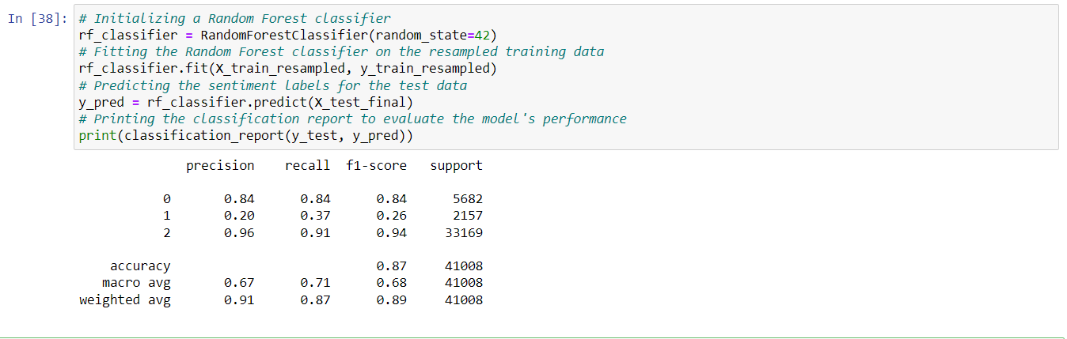

**XGBoost Classifier Model**

XGBoost (Extreme Gradient Boosting) is a powerful machine learning algorithm that excels in handling complex tasks and achieving high predictive accuracy. Here are the key performance metrics obtained from the XGBoost classifier:

**Precision:**

- Negative sentiment (class 0): 0.84

- Neutral sentiment (class 1): 0.20

- Positive sentiment (class 2): 0.96

**Recall:**

- Negative sentiment (class 0): 0.83

- Neutral sentiment (class 1): 0.37

- Positive sentiment (class 2): 0.91

**F1-score:**

- Negative sentiment (class 0): 0.84

- Neutral sentiment (class 1): 0.26

- Positive sentiment (class 2): 0.94

**Support:**

- Negative sentiment (class 0): 5682

- Neutral sentiment (class 1): 2157

- Positive sentiment (class 2): 33169

**Accuracy: 0.87**

These results indicate that the XGBoost model achieved relatively high precision and recall for the negative and positive sentiments, but lower performance for the neutral sentiment. It's important to consider these performance metrics when interpreting the model's predictions.

Overall, the XGBoost model shows promise in classifying sentiments in the Flipkart dataset. Further analysis and optimization can be done to improve the model's performance on the neutral sentiment class.

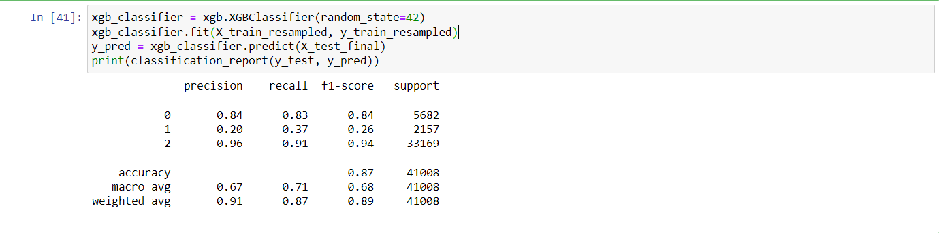

We trained logistic regression, XGBoost, and random forest models and evaluated their performance using various metrics such as precision, recall, and F1-score.

The logistic regression model achieved an accuracy of 85% and demonstrated relatively high precision and recall for the negative and positive sentiments. The XGBoost model achieved an accuracy of 87% and showed improved performance for the neutral sentiment class compared to logistic regression. The random forest model also performed well with an accuracy of 87% and balanced precision and recall across sentiment classes.

Based on the evaluation results, all three models showed promising performance in sentiment classification. However, it is important to note that the neutral sentiment class was more challenging to classify accurately.

**Recommendations:**

Based on the evaluation of the sentiment analysis models, the following recommendations are suggested:

**Feature Engineering:** Explore additional features to enhance the models' performance. Incorporate contextual information such as product categories, customer demographics, or temporal factors. These features can provide valuable insights and improve the models' ability to capture nuanced sentiment in customer reviews.

**Advanced Natural Language Processing Techniques:** Consider utilizing advanced NLP techniques like word embeddings (e.g., Word2Vec, GloVe) or deep learning models (e.g., LSTM, Transformer) to further enhance the models' performance. These techniques can capture semantic relationships and contextual information, leading to better sentiment classification.

**Ensemble Methods:** Investigate ensemble methods such as model averaging or stacking to combine the predictions of multiple models. This can help mitigate the limitations of individual models and improve overall performance by leveraging the strengths of different algorithms.